|  |  |  |  |  |
| --- | --- | --- | --- | --- |
| Fecha | Versión | Incidencias | Entrega | Comentario |
| 24/11/2022 | Inicial | 8 |  | No se ha podido probar la funcionalidad al no mostrarse los registros en la tabla. |
| 02/12/2022 |  | 5 |  |  |
| 13/12/2022 | v.2 | 5 | 13/12/2022 13:04 | No se habilita el botón de Descartar. Error al no incluir el comentario en la entrega. |
| 22/12/2022 | v.3 | 4 | 21/12/2022 | Ya se habilita el botón de descartar, pero no hace nada. |
| 10/03/2023 | v.4 | 2 | 10/03/2023 | La funcionalidad de excepción no funciona. Controlar error por contraseña incorrecta. |
| 31/03/2023 | v.5 | 2 | 23/03/2023 | Se corrigen las incidencias anteriores. Se añaden nuevas |
| 10/05/2023 | v.6 | 0 | 10/05/2023 | Se han solucionado las incidencias reportadas. |
| 10/05/2023 | v.7 | 1 | 11/05/2023 | Se detecta una incidencia que no habíamos visto |
| 22/05/2023 | v.8 | 2 | 18/05/2023 | Nueva incidencia, no se encuentra el log cuando hay error de conexión. |

**PANTALLA EJECUTAR**

1. Si procesamos una petición con sólo un script, y éste da error, podemos pulsar el botón Excepción y su estado cambia a Excepción. Una vez hecho esto, deberían desactivarse los botones Reparar (pues ya no está como error) y Excepción.

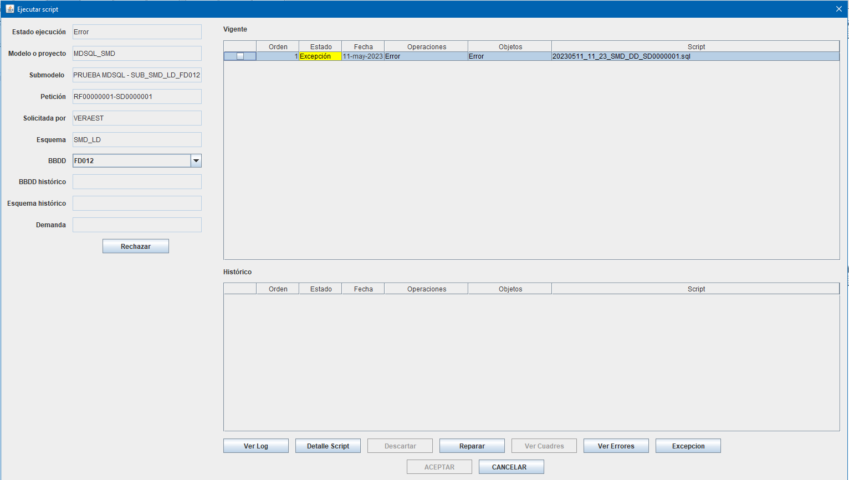

Además, al no haber ya scripts en estado Error o descuadrado, debería abrirse la pantalla Resumen Procesado.

El documento pone:

*Cada vez que se ejecute un script se irán actualizando los datos de los estados del script y el procesado.*

*Una vez ejecutados todos los scripts sin errores ni descuadres y el estado del procesado sea Ejecutado se cerrará la pantalla de ejecución de script y se mostrará la ventana de Resumen Procesado.*

1. Cuando se ejecuta un script con contraseña incorrecta, sale este error en pantalla:

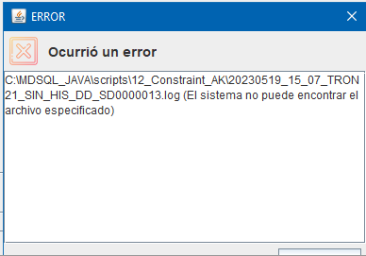

Si vamos a la carpeta, el fichero log no está. Este error no se produce con la versión anterior.

En la consola Java vemos lo siguiente, justo después de la conexión a Oracle:

14:34:11.423 [AWT-EventQueue-0] INFO c.m.b.service.impl.ScriptServiceImpl - sqlplus XXXX_LD/xxxx@FD012 @C:\MDSQL_JAVA\scripts\12_Constraint_AK\Lanza_20230522_14_33_TRON21_SIN_HIS_DD_SD.sql

14:34:11.454 [AWT-EventQueue-0] INFO c.m.b.service.impl.ScriptServiceImpl - [ScriptService.executeScriptFile] Inicio Ejecucion fichero: C:\MDSQL_JAVA\scripts\12_Constraint_AK\Lanza_20230522_14_33_TRON21_SIN_HIS_DD_SD.sql

14:34:11.689 [AWT-EventQueue-0] INFO c.m.b.service.impl.ScriptServiceImpl -

14:34:11.720 [AWT-EventQueue-0] INFO c.m.b.service.impl.ScriptServiceImpl - SQL*Plus: Release 11.2.0.1.0 Production on Lun May 22 14:34:11 2023

14:34:11.720 [AWT-EventQueue-0] INFO c.m.b.service.impl.ScriptServiceImpl -

14:34:11.720 [AWT-EventQueue-0] INFO c.m.b.service.impl.ScriptServiceImpl - Copyright (c) 1982, 2010, Oracle. All rights reserved.

14:34:11.720 [AWT-EventQueue-0] INFO c.m.b.service.impl.ScriptServiceImpl -

14:34:12.892 [AWT-EventQueue-0] INFO c.m.b.service.impl.ScriptServiceImpl - ERROR:

14:34:12.892 [AWT-EventQueue-0] INFO c.m.b.service.impl.ScriptServiceImpl - ORA-01017: nombre de usuario/contrase├▒a no v├ílidos; conexi├│n denegada

14:34:12.908 [AWT-EventQueue-0] INFO c.m.b.service.impl.ScriptServiceImpl - [ScriptService.executeScriptFile] Fin Ejecucion exitCode: 1

14:34:12.908 [AWT-EventQueue-0] ERROR c.m.b.service.impl.ScriptServiceImpl - [ScriptService.executeScripts] Error

java.io.FileNotFoundException: C:\MDSQL_JAVA\scripts\12_Constraint_AK\20230522_14_33_TRON21_SIN_HIS_DD_SD.log (El sistema no puede encontrar el archivo especificado)

at java.io.FileInputStream.open0(Native Method)

at java.io.FileInputStream.open(Unknown Source)

at java.io.FileInputStream.<init>(Unknown Source)

at com.mdsql.utils.MDSQLAppHelper.writeFileToLines(MDSQLAppHelper.java:107)

at com.mdsql.bussiness.service.impl.ScriptServiceImpl.executeScripts(ScriptServiceImpl.java:328)

at com.mdsql.ui.listener.PantallaEjecutarScriptsListener.eventBtnAceptar(PantallaEjecutarScriptsListener.java:251)

at com.mdsql.ui.listener.PantallaEjecutarScriptsListener.actionPerformed(PantallaEjecutarScriptsListener.java:90)

at javax.swing.AbstractButton.fireActionPerformed(Unknown Source)

at javax.swing.AbstractButton$Handler.actionPerformed(Unknown Source)

at javax.swing.DefaultButtonModel.fireActionPerformed(Unknown Source)

at javax.swing.DefaultButtonModel.setPressed(Unknown Source)

at javax.swing.plaf.basic.BasicButtonListener.mouseReleased(Unknown Source)

at java.awt.Component.processMouseEvent(Unknown Source)

at javax.swing.JComponent.processMouseEvent(Unknown Source)

at java.awt.Component.processEvent(Unknown Source)

at java.awt.Container.processEvent(Unknown Source)

at java.awt.Component.dispatchEventImpl(Unknown Source)

at java.awt.Container.dispatchEventImpl(Unknown Source)

at java.awt.Component.dispatchEvent(Unknown Source)

at java.awt.LightweightDispatcher.retargetMouseEvent(Unknown Source)

at java.awt.LightweightDispatcher.processMouseEvent(Unknown Source)

at java.awt.LightweightDispatcher.dispatchEvent(Unknown Source)

at java.awt.Container.dispatchEventImpl(Unknown Source)

at java.awt.Window.dispatchEventImpl(Unknown Source)

at java.awt.Component.dispatchEvent(Unknown Source)

at java.awt.EventQueue.dispatchEventImpl(Unknown Source)

at java.awt.EventQueue.access$500(Unknown Source)

at java.awt.EventQueue$3.run(Unknown Source)

at java.awt.EventQueue$3.run(Unknown Source)

at java.security.AccessController.doPrivileged(Native Method)

at java.security.ProtectionDomain$JavaSecurityAccessImpl.doIntersectionPrivilege(Unknown Source)

at java.security.ProtectionDomain$JavaSecurityAccessImpl.doIntersectionPrivilege(Unknown Source)

at java.awt.EventQueue$4.run(Unknown Source)

at java.awt.EventQueue$4.run(Unknown Source)

at java.security.AccessController.doPrivileged(Native Method)

at java.security.ProtectionDomain$JavaSecurityAccessImpl.doIntersectionPrivilege(Unknown Source)

at java.awt.EventQueue.dispatchEvent(Unknown Source)

at java.awt.EventDispatchThread.pumpOneEventForFilters(Unknown Source)

at java.awt.EventDispatchThread.pumpEventsForFilter(Unknown Source)

at java.awt.EventDispatchThread.pumpEventsForFilter(Unknown Source)

at java.awt.WaitDispatchSupport$2.run(Unknown Source)

at java.awt.WaitDispatchSupport$4.run(Unknown Source)

at java.awt.WaitDispatchSupport$4.run(Unknown Source)

at java.security.AccessController.doPrivileged(Native Method)

at java.awt.WaitDispatchSupport.enter(Unknown Source)

at java.awt.Dialog.show(Unknown Source)

at java.awt.Component.show(Unknown Source)

at java.awt.Component.setVisible(Unknown Source)

at java.awt.Window.setVisible(Unknown Source)

at java.awt.Dialog.setVisible(Unknown Source)

at com.mdval.ui.utils.UIHelper.show(UIHelper.java:63)

at com.mdsql.ui.listener.FramePrincipalActionListener.evtEjecutar(FramePrincipalActionListener.java:427)

at com.mdsql.ui.listener.FramePrincipalActionListener.actionPerformed(FramePrincipalActionListener.java:94)

at javax.swing.AbstractButton.fireActionPerformed(Unknown Source)

at javax.swing.AbstractButton$Handler.actionPerformed(Unknown Source)

at javax.swing.DefaultButtonModel.fireActionPerformed(Unknown Source)

at javax.swing.DefaultButtonModel.setPressed(Unknown Source)

at javax.swing.plaf.basic.BasicButtonListener.mouseReleased(Unknown Source)

at java.awt.AWTEventMulticaster.mouseReleased(Unknown Source)

at java.awt.Component.processMouseEvent(Unknown Source)

at javax.swing.JComponent.processMouseEvent(Unknown Source)

at java.awt.Component.processEvent(Unknown Source)

at java.awt.Container.processEvent(Unknown Source)

at java.awt.Component.dispatchEventImpl(Unknown Source)

at java.awt.Container.dispatchEventImpl(Unknown Source)

at java.awt.Component.dispatchEvent(Unknown Source)

at java.awt.LightweightDispatcher.retargetMouseEvent(Unknown Source)

at java.awt.LightweightDispatcher.processMouseEvent(Unknown Source)

at java.awt.LightweightDispatcher.dispatchEvent(Unknown Source)

at java.awt.Container.dispatchEventImpl(Unknown Source)

at java.awt.Window.dispatchEventImpl(Unknown Source)

at java.awt.Component.dispatchEvent(Unknown Source)

at java.awt.EventQueue.dispatchEventImpl(Unknown Source)

at java.awt.EventQueue.access$500(Unknown Source)

at java.awt.EventQueue$3.run(Unknown Source)

at java.awt.EventQueue$3.run(Unknown Source)

at java.security.AccessController.doPrivileged(Native Method)

at java.security.ProtectionDomain$JavaSecurityAccessImpl.doIntersectionPrivilege(Unknown Source)

at java.security.ProtectionDomain$JavaSecurityAccessImpl.doIntersectionPrivilege(Unknown Source)

at java.awt.EventQueue$4.run(Unknown Source)

at java.awt.EventQueue$4.run(Unknown Source)

at java.security.AccessController.doPrivileged(Native Method)

at java.security.ProtectionDomain$JavaSecurityAccessImpl.doIntersectionPrivilege(Unknown Source)

at java.awt.EventQueue.dispatchEvent(Unknown Source)

at java.awt.EventDispatchThread.pumpOneEventForFilters(Unknown Source)

at java.awt.EventDispatchThread.pumpEventsForFilter(Unknown Source)

at java.awt.EventDispatchThread.pumpEventsForHierarchy(Unknown Source)

at java.awt.EventDispatchThread.pumpEvents(Unknown Source)

at java.awt.EventDispatchThread.pumpEvents(Unknown Source)

at java.awt.EventDispatchThread.run(Unknown Source)